WORK-CASE №5

1

***Виконав студент Корольов Є.***

1.1

Mounting allows the system to specify the place (directory) in which the directory tree of the connected disk or partition will be built, the so-called mount point. Using this mechanism allows you to easily connect an external data storage device with any type of file system to the system.

Basic steps:

Device Identification – The operating system identifies the device to be mounted.

Specifying the mount point - the user selects a directory where the contents of the device will be available (for example, /mnt/usb).

Mount - The mount command mounts the device's file system to the selected mount point, providing access to the data through that directory.

Виконала студентка Коваленко С.

1.2

Automatic detection:

- Windows: Automatic device detection and configuration usually occurs without user intervention. Windows provides drivers for many devices by default or through the Update Center.

- Linux: While many devices are also automatically detected, additional settings or drivers may be required for specific devices.

Manage drivers:

- Windows: Drivers are often installed automatically through Windows Update or can be downloaded from the manufacturer's website.

- Linux: Drivers can be open source or closed source and may require more effort to install (through a package manager or manually).

Graphical interface:

- Windows: The interface for configuring devices is usually simpler and more intuitive for users.

- Linux: Configuration can be done through graphical interfaces (e.g. CUPS for printers) or through a terminal, which can be more difficult for newcomers.

Access control:

- Windows: Usually less strict access control to devices.

- Linux: Uses access control mechanisms that may require a password for certain actions, which provides an additional layer of security.

Interaction with file systems:

- Windows: Supports mainly NTFS and FAT32.

- Linux: Supports a variety of file systems, such as ext4, Btrfs, XFS, as well as FAT32 and NTFS, which provides more flexibility.

***Виконав студент Горохов Д.***

2. Підключіть до вашої віртуальної машини зі встановленою ОС Linux флешку та принтер (за можливості) та через графічний інтерфейс скопіюйте один файл з флешки на віртуальну машину та роздрукуйте його (такі ж самі дії повторіть, але з іншим файлом через команди в терміналі).

I decided to connect the USB flash drive and recognize it using the Extension Pack Manager, this is a general extension of the Virtual Box, for working with input files. To do this, you need to download the extension, you need to determine the version of the Virtual Box(I have 7.1.0)

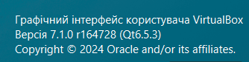

Then download the extension via the Internet:

Open the tab with the extension, and load it from your PC: 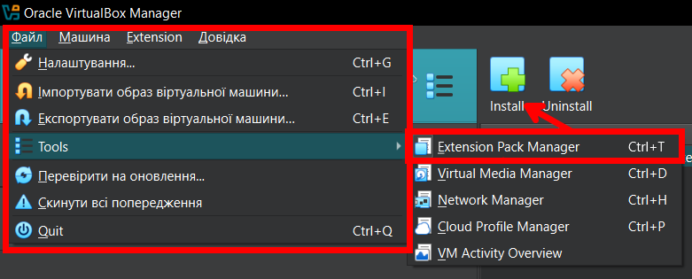

Next, for the virtual machine, you need to specify the device that you want to connect via USB (in my case, a USB flash drive, since I don't have a printer). 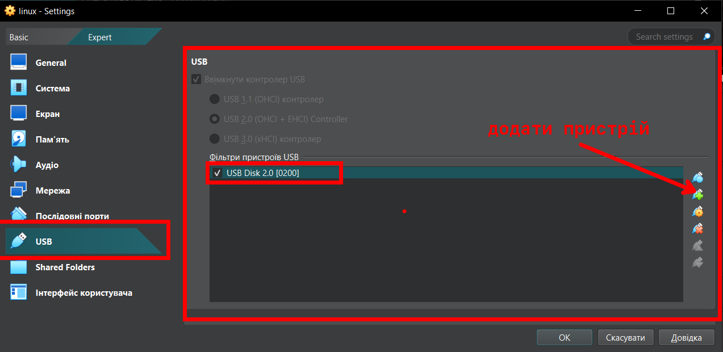

After launching, we see the connected USB flash drive and can transfer files through it. 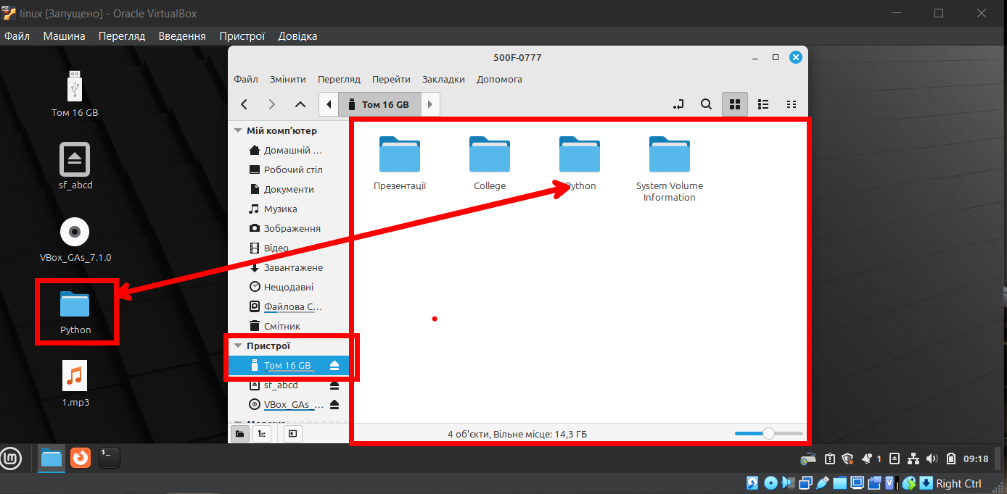

Unfortunately, I don't have a printer. Therefore, I will describe the steps on how to extract a file that is necessary, for this you can open any text editor (I will use LibreOffice Writer as an example). Click File -> Print

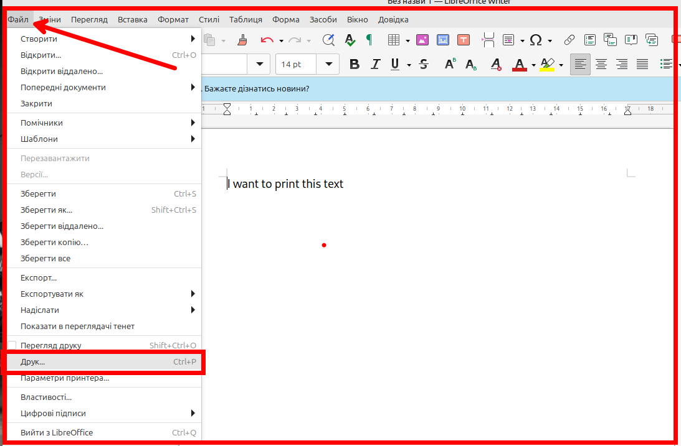

When we click on it, we get a modal window:  
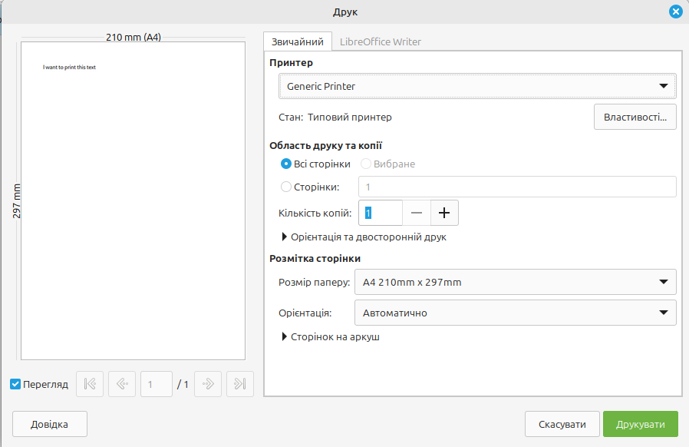

All that's left is to press print, provided that the printer is connected.

Copying a file from a USB flash drive, through the terminal:

Enter the command lsblk and find the USB flash drive in the list: 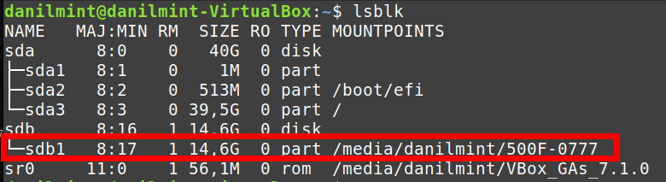

To copy, use the command cp /media/user-name/file_name ~/, where we specify the name of the file, and where we want to copy (I will copy the file from the Python folder).



The file was successfully copied to the home directory. 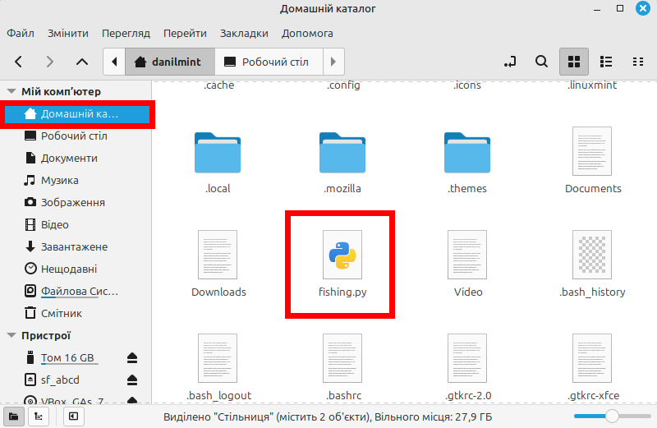

If the printer is connected to the system, use the command lp ~/name'я_файлу.txt(in this case, the file will be copied from the home directory): 

At the end, we received a message that the printer was not configured in the system.